Tutorial 2: Steps to create a component from schematic

For large designs a modular approach has to be used to create the design where some of the components to be used have to made separately prior to the top level schematic. This can be done using the following steps:

1. Create the schematic of the component you want to make.
2. Go to Tools --> Symbol Wizard

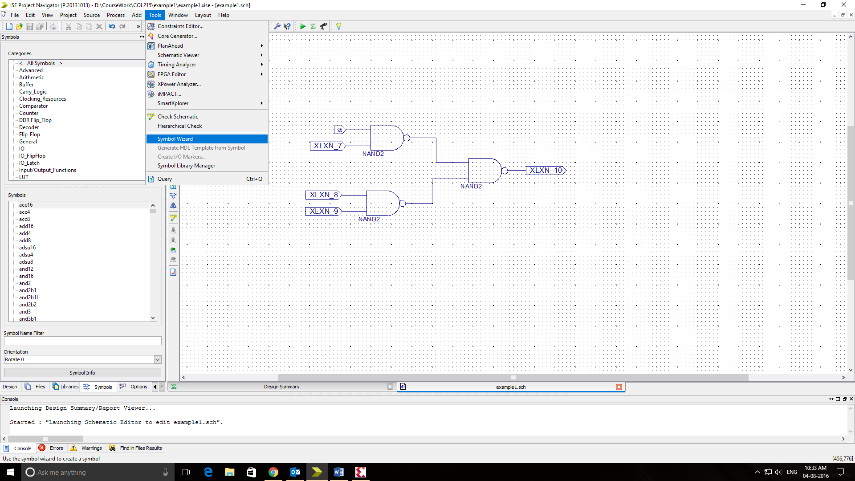

1. In Pin Name Source, select “Using Schematic” and select the schematic you want to create a component for. Click Next.

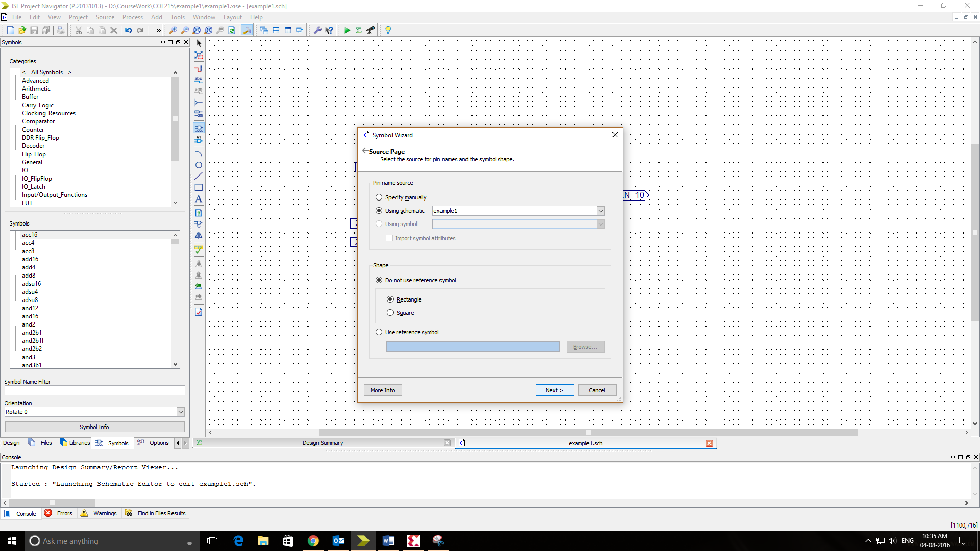

1. Set the order so that you can get the desired order of pins on the schematic symbol. Click Next.

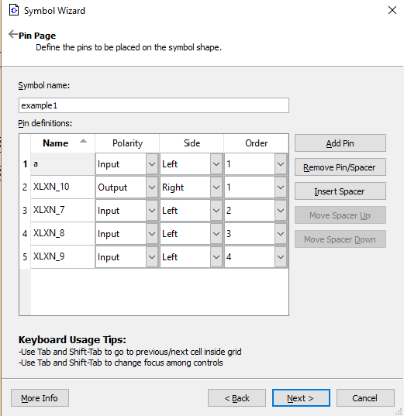

1. Click Next --> Finish after making sure the Preview is as expected.
2. Now, create a new schematic where you want to use the component just made. Click on “Add Symbol” icon. In the list of sources, you should be able to see your newly created symbol.

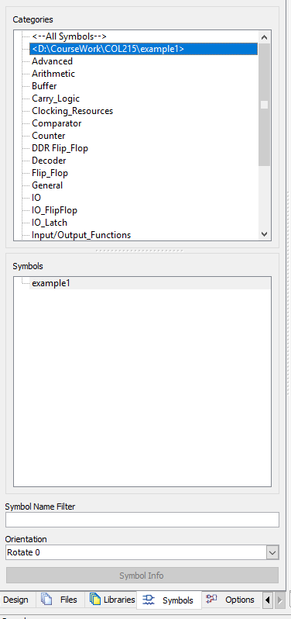

1. Select the Symbol just made and use it in your schematic.
2. Make sure that the schematic which uses other components should be set as top level module during Synthesis. (Right Click --> Set as top module).